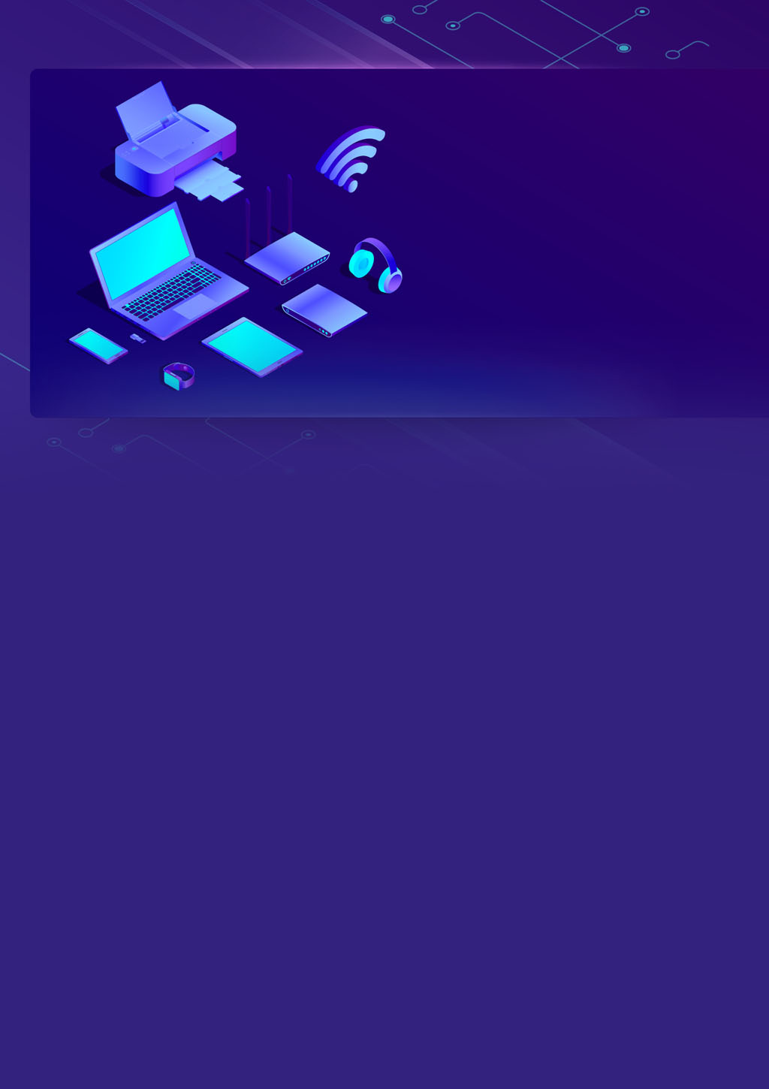

**Assignment**

**Cloud**

**IOT internship**

**Team Members: -**

**TL: Mahmoud Essam Fathy: 20221460231**

**Ziad Ashraf Hafez Gaber: 20221374025**

**Ziad Ashraf Ibrahim Taher: 20221369225**



**Assignment – Cloud – Theoires : OSI Model vs TCP/IP**

**What is OSI Model?**

**The OSI Model is a logical and conceptual model that defines network communication used by systems open to interconnection and communication with other systems**

**What is TCP/IP Model?**

**TCP/IP helps you to determine how a specific computer should be connected to the internet and how you can transmit data between them. It helps you to create a virtual network when multiple computer networks are connected.**

|  |  |
| --- | --- |
| **OSI Model** | **TCP/IP Model** |
| **It is developed by ISO (International Standard Organization)** | **It is developed by ARPANET (Advanced Research Project Agency Network).** |
| **OSI model provides a clear distinction between interfaces, services, and protocols.** | **TCP/IP doesn’t have any clear distinguishing points between services, interfaces, and protocols.** |
| **OSI refers to Open Systems Interconnection.** | **TCP refers to Transmission Control Protocol.** |
| **OSI uses the network layer to define routing standards and protocols.** | **TCP/IP uses only the Internet layer.** |
| **OSI layers have seven layers.** | **TCP/IP has four layers.** |
| **In the OSI model, the transport layer is only connection-oriented.** | **A layer of the TCP/IP model is both connection-oriented and connectionless.** |
| **In the OSI model, the data link layer and physical are separate layers.** | **In TCP, physical and data link are both combined as a single host-to-network layer.** |



**Assignment – Cloud : HTTP and its different versions**

**HTTP (Hypertext Transfer Protocol) is the fundamental protocol of the World Wide Web, created by Tim Berners-Lee and his team in the late 1980s to early 1990s. Since its inception, HTTP has undergone significant changes to maintain its simplicity and adapt to the evolving web landscape. Originally designed for file exchange in a controlled environment, it has evolved into a versatile protocol capable of transmitting high-resolution images, videos, and even 3D content over the internet.**

**HTTP/0.9 and HTTP/1.0, which were designed for basic file exchange, to the more advanced HTTP/1.1 and HTTP/2, which introduced features like persistent connections and multiplexing**

**And HTTP 3 QUIC is a protocol designed to significantly reduce latency in HTTP connections. Unlike HTTP/2, which runs over a single TCP connection, QUIC operates over UDP and supports multiple streams. This allows packet loss detection and retransmission to be handled independently for each stream, preventing the blocking of all streams in case of errors. By implementing these mechanisms, QUIC aims to improve the efficiency and responsiveness of HTTP connections, leading to a faster and more reliable web browsing experience.**

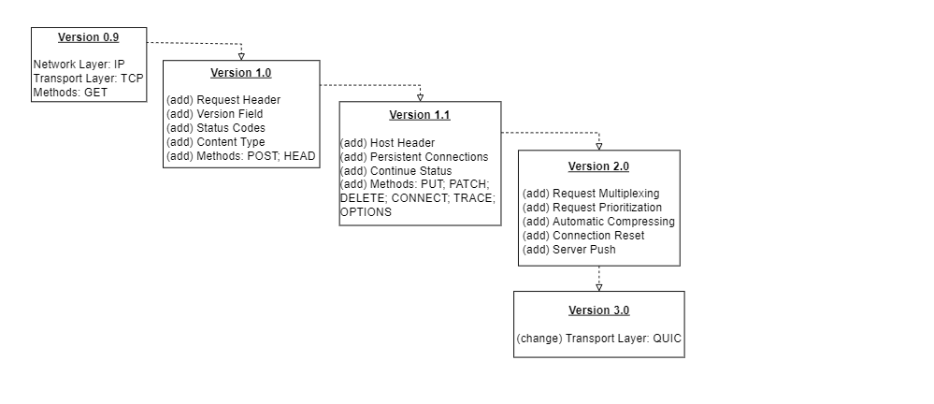



**Assignment – Cloud – Theoires : Pub/sub model**

**What is pub/sub messaging?**

Publish-subscribe messaging, or pub/sub messaging, is an asynchronous communication model that makes it easy for developers to build highly functional and architecturally complex applications in the cloud. In modern cloud architecture, applications are decoupled into smaller, independent building blocks called *services*. Pub/sub messaging provides instant event notifications for these distributed systems. It supports scalable and reliable communication between independent software modules.

## **How does pub/sub messaging work?**

The publish-subscribe (pub/sub) system has four key components.

### **Messages**

### **Topics**

### **Subscribers**

### **Publishers**

## **What are the benefits of pub/sub messaging?**

The publish-subscribe (pub/sub) model enables [event-driven architecture](https://aws.amazon.com/event-driven-architecture/), which is required in several modern applications. You can use events to trigger and communicate between decoupled services. An event is a change in state, or an update, like an item being placed in a shopping cart.

Pub/sub messaging provides significant advantages to developers who build applications that rely on real-time events. We outline some of the advantages below.

### **Eliminate polling**

### **Dynamic targeting**

### **Decouple and scale independently**

### **Simplify communication**

### **Durability**

### **Security**



**Assignment – Cloud – MQTT Protocol**

What’s MQTT “**Message Queuing Telemetry Transport”** Protocol?  
**MQTT: is a standards-based messaging protocol, or set of rules, used for machine-to-machine communication.**

**Smart sensors, wearables, and other Internet of Things (IoT) devices** typically have to **transmit** and **receive** data over a resource-constrained network with limited bandwidth

for **data** **transmission**, as it is easy to implement and can communicate IoT data efficiently.

MQTT supports messaging between **devices to the cloud and the cloud to the device**.

* **Lightweight and efficient**

### **Scalable**

### **Reliable**

### **Secure**

### **Well-supported**

**Side Question:**

**DOES FIREBASE FOLLOW MQTT PROTOCOL ?**

**Answer:**

**No, Firebase primarily uses its own Realtime Database and Firestore as its real-time database solutions, and these don't use the MQTT (Message Queuing Telemetry Transport) protocol by default.**

**Firebase Realtime Database uses a WebSocket-based protocol to maintain real-time synchronization between clients and the database, while Firestore uses a combination of WebSockets and HTTP/2.**

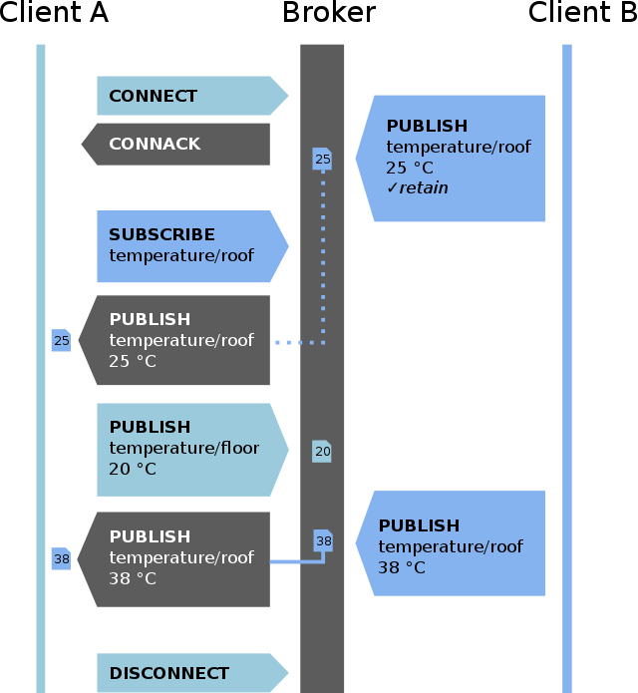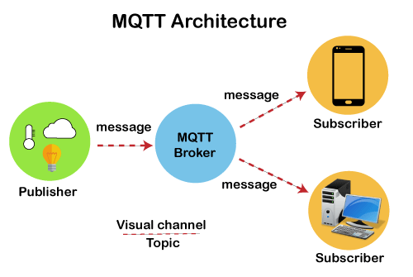

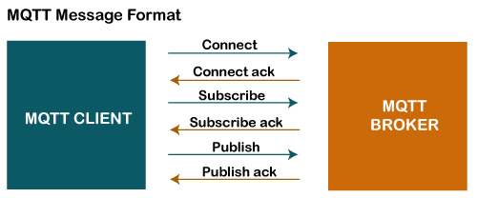



**Assignment – Cloud – Theoires : ID token vs Access Token**

**ID tokens and access tokens are both used in OAuth 2.0 and OpenID Connect to authenticate users and authorize them to access protected resources. However, they have different purposes and are used in different ways.**

|  |  |  |
| --- | --- | --- |
| **X** | **Access token** | **ID Token** |
| **Purpose** | **The access token is used to authorize access to specific resources on behalf of a user** | **The ID token is primarily used for authentication and user identification** |
| **Content** | **The access token carries information about the user's granted permissions, scopes, and potentially other metadata that the resource server uses to determine whether the user has the necessary privileges to access a particular resource.** | **The ID token typically contains claims like user ID, name, email, and potentially other user-related information** |
| **Usage** | **The access token is sent by the client application to the resource server when making API requests.** | **The ID token is often sent to the client application after successful authentication via an OpenID Connect flow** |
| **Scope** | **The access token is requested with scopes that define the level of access the application needs.** | **The ID token is requested with the openid scope** |

**In summary, the ID token is primarily used for authentication and user identification, allowing the client application to know who the user is without making additional requests to the identity provider. On the other hand, the access token is used for authorization, granting the client application permission to access specific resources on behalf of the user.**



**Assignment – Cloud – Firebase Realtime Database**

**Firebase Realtime Database**

**Store and sync data with our NoSQL cloud database.**

**Data is synced across all clients in realtime, and remains available when your app goes offline.**

**Data is stored as JSON and synchronized in realtime to every connected client.**

**Realtime: Firebase Realtime Database uses data synchronization—every time data changes, any connected device receives that update within milliseconds.**

**Offline : Firebase apps remain responsive even when offline because the Firebase Realtime Database SDK persists your data to disk.**

**Accessibility : The Firebase Realtime Database can be accessed directly from a mobile device or web browser; there’s no need for an application server.**

